VKV GOVERNMENT DEGREE COLLEGE
KOTHAPETA Dr.B.R.AMBEDKAR KONASEEMA DT. AP
AFFILIATED BY ADIKAVI NANNAYA UNIVERSITY
ACCREDITED BY NAAC WITH “B” GRADE
DEPARTMENT OF HISTORY

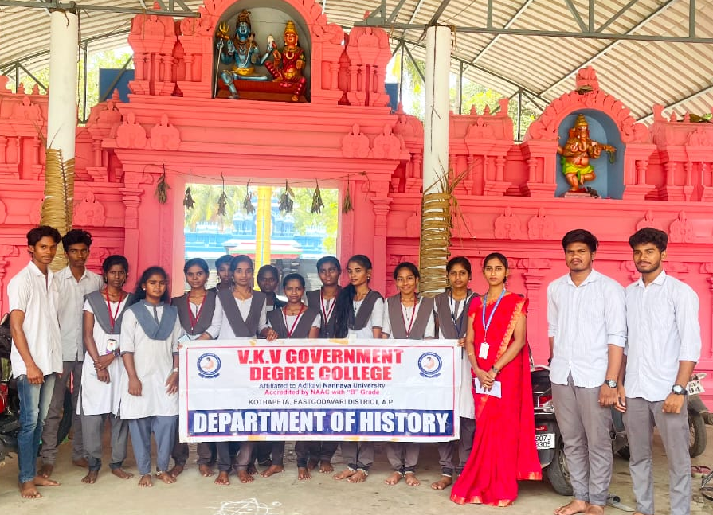

DEPARTMENT OF
HISTORY
ACTION PLAN
FOR 2024-25


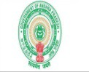
V.K.V. GOVERNMENT DEGREE COLLEGE, KOTHAPETA
DEPARTMENT OF HISTORY
(Accredited by NAAC “B” Grade)
(An ISO 9001:2015 and 14001:2015 Certified College)

Action Plan for the Academic Year-2024-25

S.NO. | MONTH/ YEAR | WEEK | PROPOSED ACTIVITIES | WHETHER CONDUCTED (YES/NO) | ALTERNATE DATE (IF NOT)/  REMARKS
2 | JULY- 2024 | I WEEK | Departmental meeting
2 | JULY- 2024 | I WEEK | Commencement of classwork for III&IV semester
2 | JULY- 2024 | I WEEK | Alluri seetha ramaraju jayanthi
2 | JULY- 2024 | II WEEK | Preparation of curricular plan
2 | JULY- 2024 | III WEEK | Clean & green
2 | JULY- 2024 | IV WEEK | Kharghil vijay diwas(
3 | AUG-2024 | I WEEK | Pingali venkayya jayanthi(
3 | AUG-2024 | I WEEK | Mentor – mantee meeting
3 | AUG-2024 | II WEEK | Departmental meeting
3 | AUG-2024 | III WEEK | Bridge course
3 | AUG-2024 | IV WEEK | Mid- 1 examinations
4 | SEPT – 2024 | I WEEK | Departmental meeting
4 | SEPT – 2024 | I WEEK | Dada bhai nouroji jayanthi(
4 | SEPT – 2024 | II WEEK | Quiz programme
4 | SEPT – 2024 | III WEEK | Mentor – mantee meeting
4 | SEPT – 2024 | IV WEEK | Clean & green
5 | OCT - 2024 | I WEEK | Gandhi jayanthi, lala bahadur sasthri jayanthi(
5 | OCT - 2024 | II WEEK | Class room seminars
5 | OCT - 2024 | II WEEK | Study projects
5 | OCT - 2024 | III WEEK | Remedial classes
5 | OCT - 2024 | IV WEEK | Mid -2 examinations
5 | OCT - 2024 | IV WEEK | Sardhar vallabhai patel jayanthi (
6 | NOV- 2024 | I WEEK | Semester term examinations for odd semester
6 | NOV- 2024 | I WEEK | Departmental meeting
6 | NOV- 2024 | II WEEK | Jawahar lal Nehru jayanthi(
6 | NOV- 2024 | III WEEK | Commencement of class work
6 | NOV- 2024 | III WEEK | Extention activity
6 | NOV- 2024 | IV WEEK | Internships
7 | DEC – 2024 | I WEEK | Departmental meeting
7 | DEC – 2024 | I WEEK | Certificate course
7 | DEC – 2024 | II WEEK | Study projects
7 | DEC – 2024 | III WEEK | Group discussion
7 | DEC – 2024 | III WEEK | Mentor – mantee meeting
7 | DEC – 2024 | IV WEEK | Clean & green
8 | JAN- 2025 | I WEEK | Departmental meeting
8 | JAN- 2025 | I WEEK | Mid – 1 examinations
8 | JAN- 2025 | II WEEK
8 | JAN- 2025 | III WEEK | Remedial classes
8 | JAN- 2025 | IV WEEK | Guest lecturedepartmental Review meeting
9  9 | FEB-2025 | I WEEK | mid – examination
9  9 | FEB-2025 | II WEEK | Mentor – mantee meeting
9  9 | FEB-2025 | III WEEK | Field trip
9  9 | FEB-2025 | IV WEEK | Pg entrance classes
10 | MAR-2025 | I WEEK | Departmental meetig
10 | MAR-2025 | I WEEK | Semester term examinations
10 | MAR-2025 | II WEEK | Extension activity or
10 | MAR-2025 | II WEEK | Extenstion lecture
10 | MAR-2025 | III WEEK | Semester term examinations for 4th semester students
10 | MAR-2025 | IV WEEK | Mytyrdom day of bhagath singh
11 | APRIL-2025 | I WEEK | Departmental ,eeting
11 | APRIL-2025 | II WEEK | Jyothi rao phule jayanthi
11 | APRIL-2025 | III WEEK | National webinar
11 | APRIL-2025 | III WEEK | Pg entrance classa in history
11 | APRIL-2025 | IV WEEK

In addition to above programmes, the department of HISTORY is conducting various Curricular, Co-curricular, Extra-Curricular Activities, Community Service Activities like Clean and Green, Swatch Bharath, Eco-Friendly activities etc., as per the Circulars issued by the CCE, A.P. APSCHE, UGC, AKNU, Govt. of India, Govt. of Andhra Pradesh, and other Govt. and Non-Govt. Organizations promptly.

Principal

Lecturer


